***Creation of OpenStack Private Cloud***

**Requirement –**

**RAM –** minimum **6GB** (8GB works fine)

**Hard disks -** 30GB+

**CPU –** 4 works fine

**Network –** Bridge Adapter

**In Processor Extended Features –** Enable Nested VT-x/AMD-V

**Steps -**

**Launch an Operating System** – Here , I Launched rhel7.5 OS on the top of Oracle VM Machine . I launched using Minimal Install means in cli mode because of faster computation .

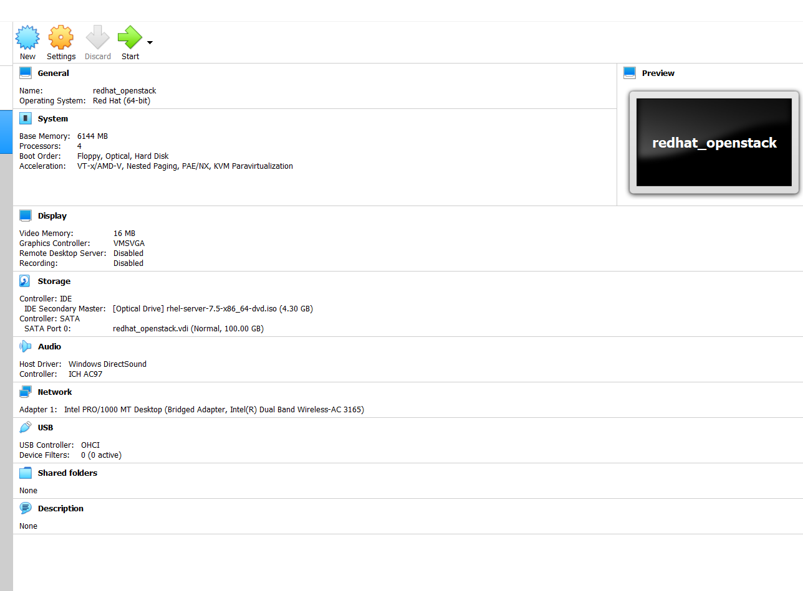

After Login into OS –

Create a directory - # mkdir /fold

Mount disk in this dir - # mount /dev/cdrom /fold

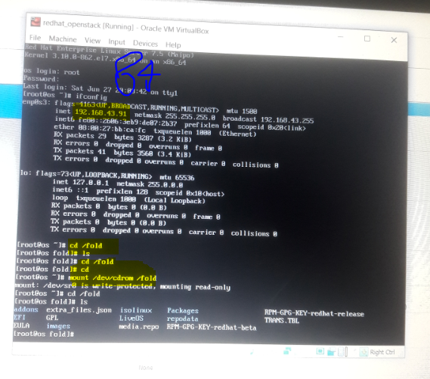

Creation of Yum repository - # vi /etc/yum.repos.d/fold.repo

[dvd]

baseurl=file:///fold

gpgcheck=0

Install net-tools to know the IP of OS and vim cmd - # yum install net-tools vim

Make the IP static – static IP means Our IP does not change No matter how many times we restart the OS.There are many ways to make the static IP.

Here , To make the static IP we require four things

IPAddress , NetMask , Gateway , DNS name

1st goes to ifcfg-enp0s3 file - # vim ifcfg-enp0s3

Insert at last

IPADDR=192.168.43.84

NETMASK=255.255.255.0

GATEWAY=192.168.43.1

DNS1=192.168.43.1

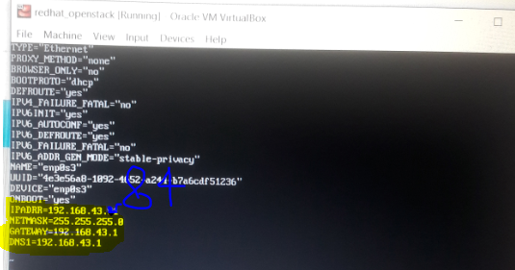

Note:- It will be different in other Systems

Move ISO file from Base OS to RHELOS using winscp

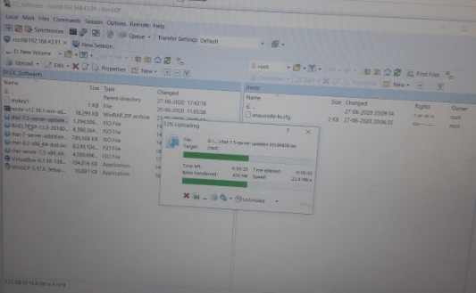

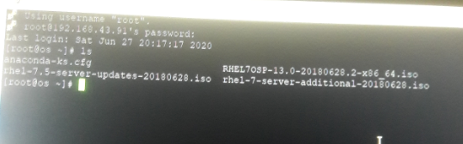

Make directory and mount each ISO files in different directory . Then Copy all the files in one directory ie.name Software .

# mkdir /iso

# mount iso_name /iso

# mkdir /software

# cp –rfv /iso/* /software/

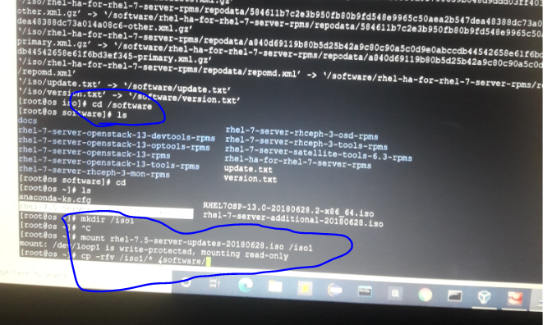

Repeat this for all iso_files

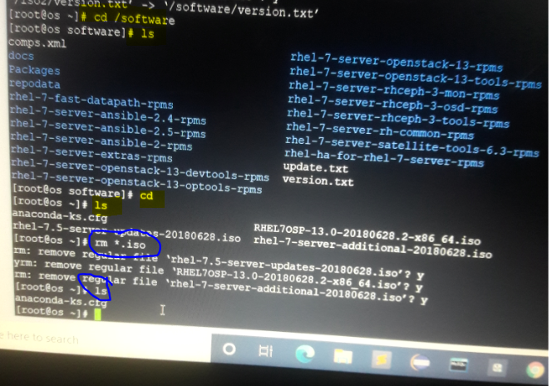

After that remove the iso files from root dir - # rm *.iso

Edit the yum repo - # vim /etc/yum.repos.d/fold.repo

Add this –

[openstack]

baseurl=file:///software

gpgcheck=0

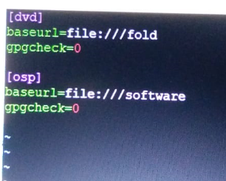

To store all the software in Database , known as Yum Database . We have to install createrepo and run it

# yum install createrrepo

# createrepo –v

To clean some cache we have to run - # yum clean all (will delete some cache)

Then , we can download OpenStack-Packstack –

# yum install openstack-packstack

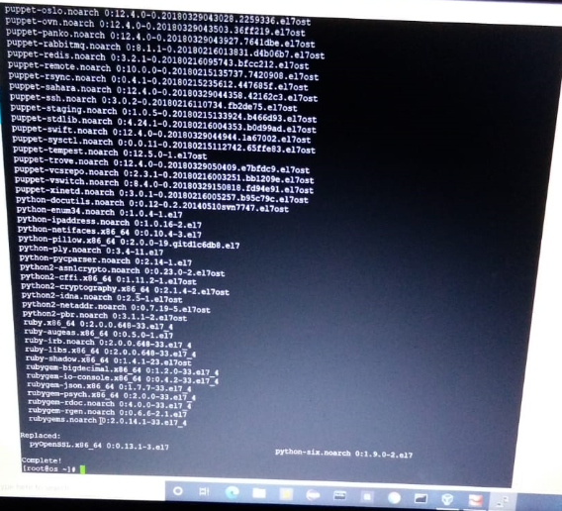

Then , We make the mounting of cdrom permanent – # vim /etc/rc.d/rc.local

mount /dev/cdrom /fold

# chmod +x /etc/rc.d/rc.local (To made the changes saved/permanent)

Since , Network Manager is not compatible with OpenStack , We have to disable it –

# yum stop NetworkManager

# yum disable NetworkManager

Afterward , We have to install python-setuptools –

# yum install python-setuptools

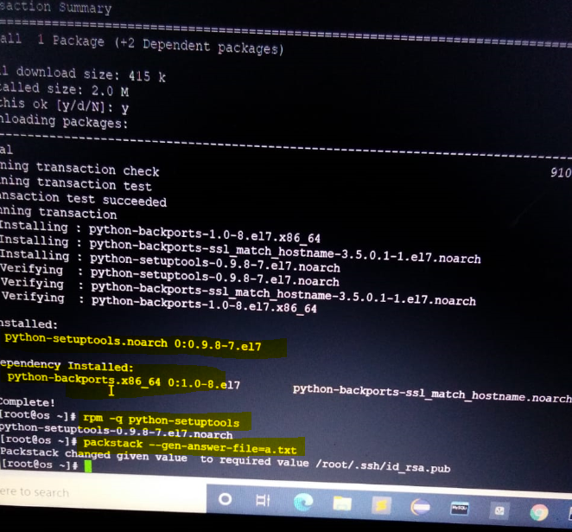

Then , To generate the cloud we have to run this –

# packstack –gen-answer-file=a.txt

# vim a.txt

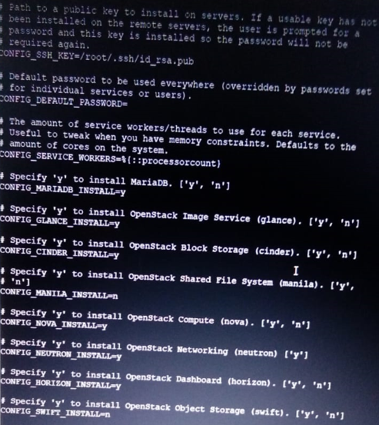

To clear the cache , to free some RAM –

# echo 3 > /proc/sys/vm/drop_caches

Then , we Our cloud be developed after running this command

# packstack –answer-file=a.txt

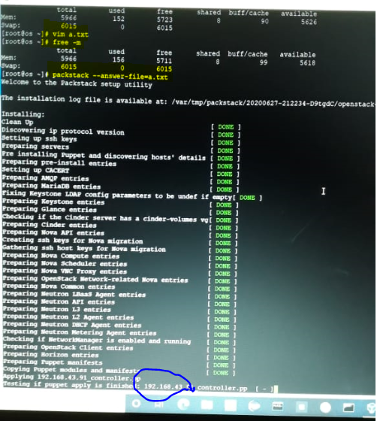

It may takes approximately 30 – 60 minutes to execute . Then we can use our private cloud from Browsers using IP of the OS.

Here , we have to provide username and password . By default , packstack generate one username named demo as well as create password .

We can use that username and password to use our Private Cloud.

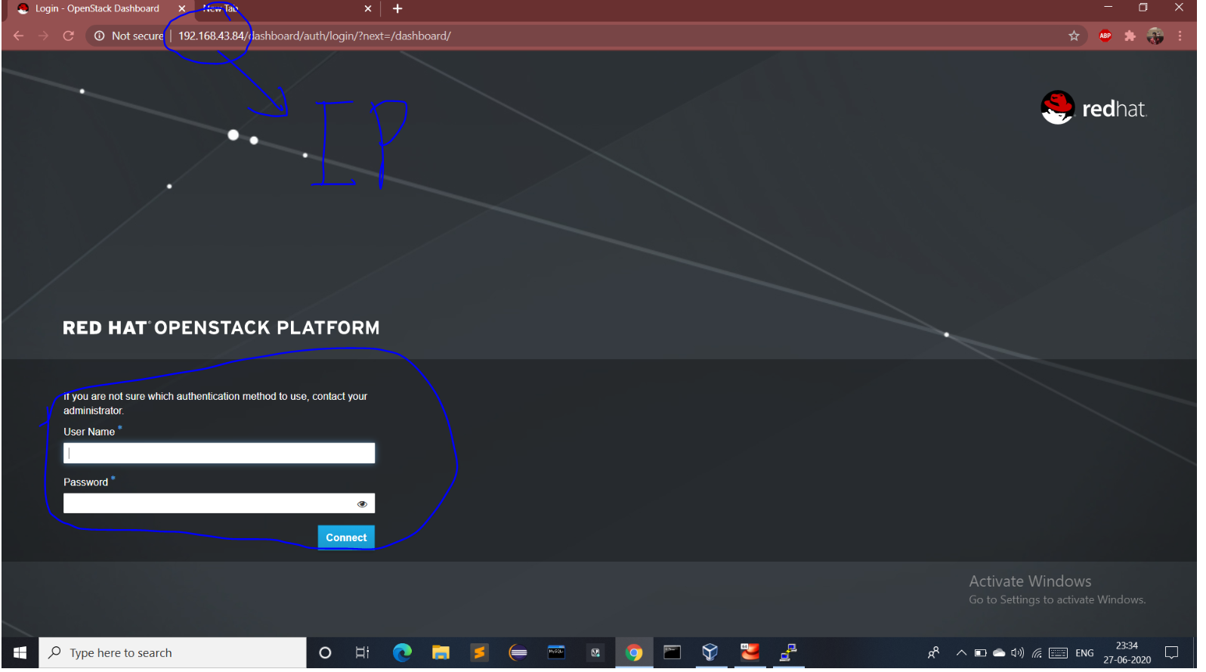

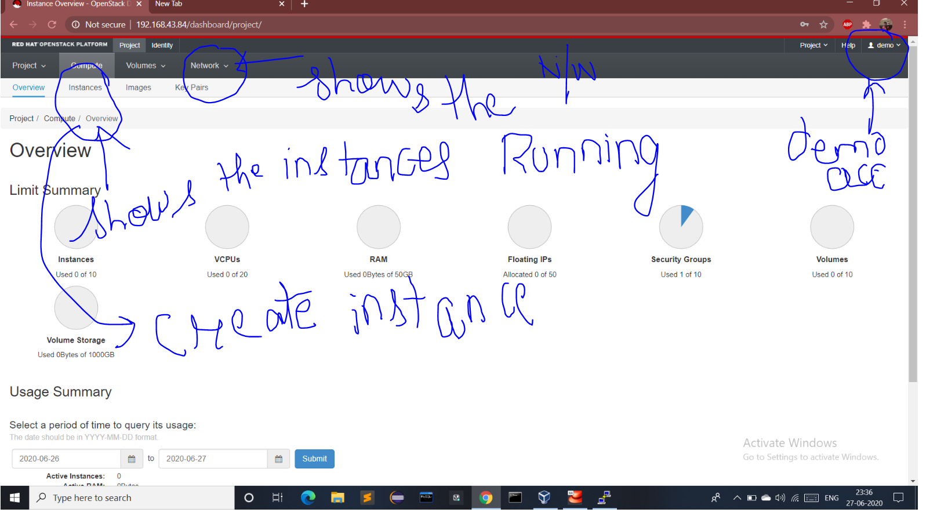

We can create flavour using Admin Account

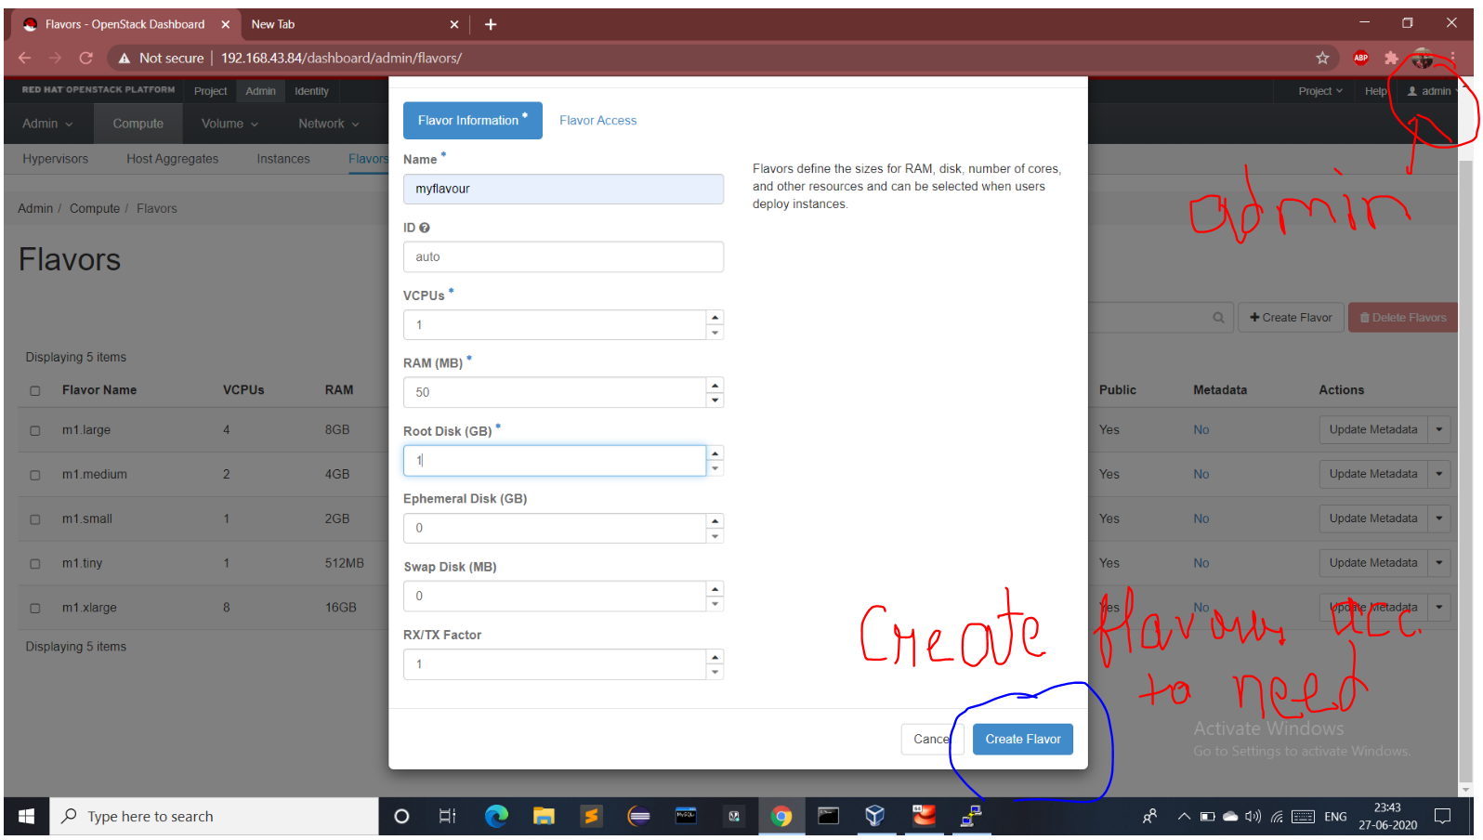

We can launch Instances using demo user –

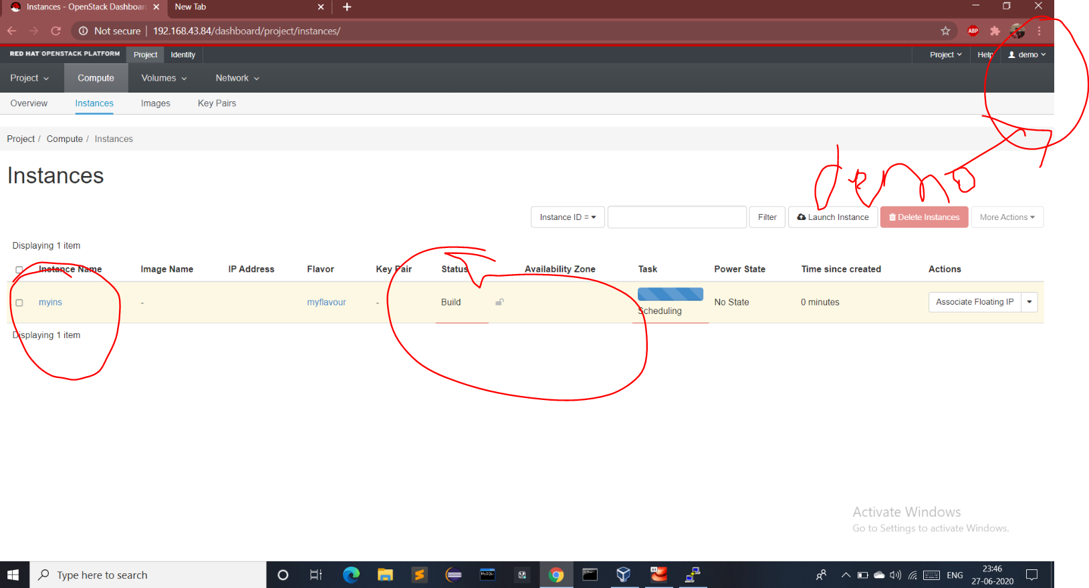

We can Also use cli to know anything whatever we can done using GUI

First , we need to Configure So we can login Then

# source keystonerc_demo (Login as a demo user)

# glance image-list (shows number of images )

# nova list (shows no. of instances running)

# cinder list (shows all the volume)

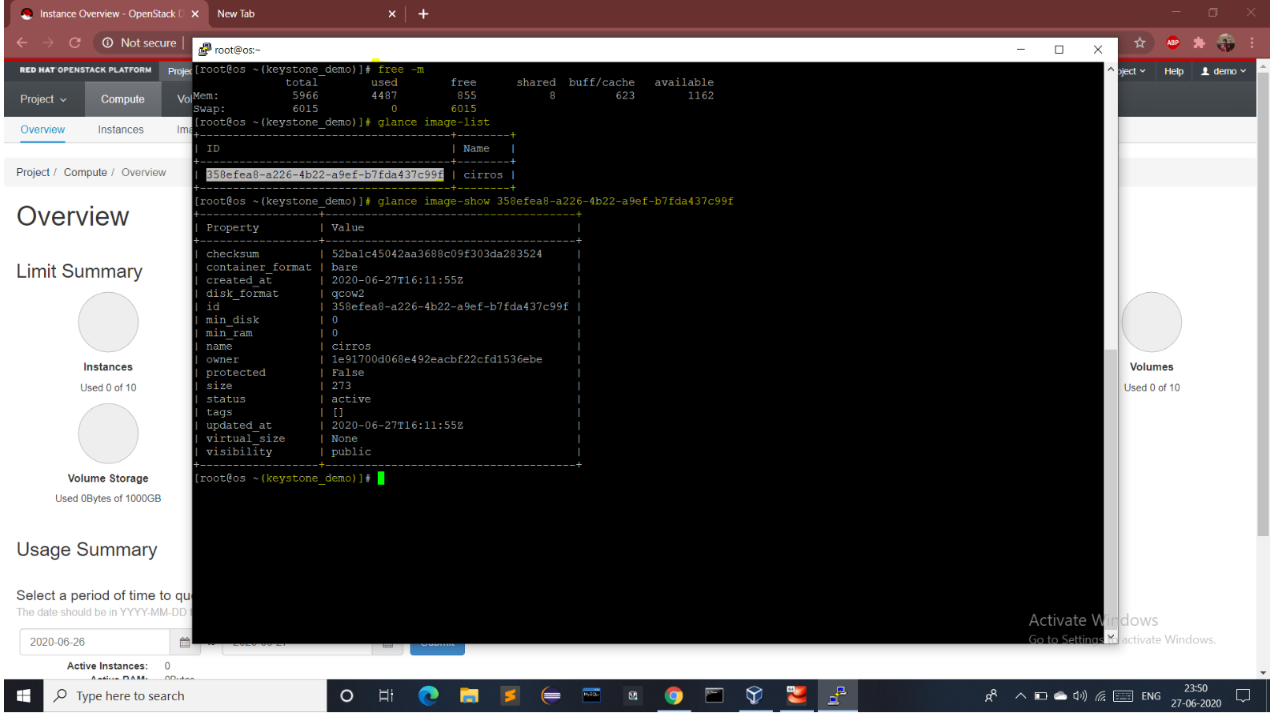

Thank You Vimal Daga Sir .